YXD- Instruction for HP Refillable cartridges
Suitable for HP950/951XL/ HP932/933XL
HP8100/HP8600/HP6100/HP7110

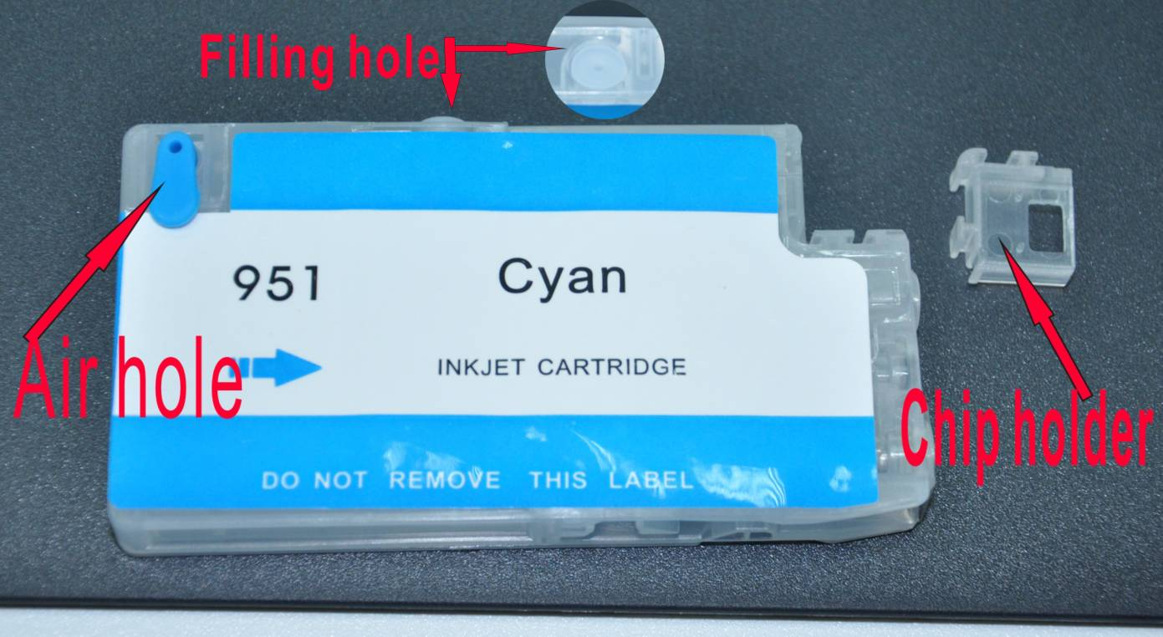

Filling steps:
Step 1：get new empty cartridge, ink and syringe with needle ready;
Step 2：Remove plugs of air hole and filling hole;
Step 3：keep syringe with ink (with needle) insert into the filling hole and fill ink;
Step 4: Fit the plugs back after finish filling.
Remove plugs of air hole after installing to printer before using.

